School of Computer Science

CMP1130m-1718 Web Authoring – Assesment 1

Website Url:

Video Url:

nathan haigh Student ID: 17643792

Introduction

This assessment for this module was to design and implement an interactive website, to examine the strengths and weaknesses of current web specifications/standards as well as techniques and methods used in construction the website. This means that the website has been designed using the newest mark-up languages, for example HTML5 and CSS3 were both utilised in the website.

In regards to ensuring the quality of the website and improving features, the designers collected user feedback which was considered carefully and subsequent changes made to the website where required. The website contains many features such as shadows, multimedia, local storage, hyperlinks, text effects, JavaScript functions and CSS3 specific properties.

Web Specifications & Standards

There are several advantages to using the latest web standards as opposed to previous or older iterations. By utilising the latest web standards and specifications it becomes easier for maintenance of web pages across a variety of devices, hence both running and maintenance costs can be reduced as the pages have interoperability over many different platforms. This is achieved by dividing up the content of the pages into categories such as presentation, functionality and content through the use of HTML5 documents with external CSS3 styling as well as JavaScript functionality. By using the current web standards the webpages can be displayed as the developer originally planned, this does not just apply to current technologies but future technologies can utilise these standards as well. Additionally, the location and positioning when using search engines can be made more efficient when using current web standards. Web standards also give greater accessibility to all types of platforms whether on hand held devices such as mobile phones, people with disabilities that could effect their viewing of the pages and even people using older browsers that have become fare less common.

Conversely there are still limitations when using current web standards and these limitation can have varying impacts on their usefulness for both the developer and the end users. When using web standards far stricter coding is needed during the developmental stages of the pages, this in turn means greater knowledge of the standards is needed in the developers, this includes knowledge and the understanding of how to use it in relation to developing interoperable web sites that are supported across different devices and browsers. Furthermore web standards could easily be considered limiting for developers as they can have the adverse effect of constraining the developers creativity and design. In order to strictly adhere to the standards so as to achieve validation from the W3C, some of the actual content of the website as well as its design may be affected.

Methods

In order to meet with current HTML5 web standards the HTML in the pages has been written using the most recent HTML elements so as to allow the website to function effectively and provide accessibility for the present and future, in doing so it is expected that the website will continue to operate efficiently and in the manner, it was designed to, allowing for easy introduction for any future web technologies that may need to be implemented. The website has been designed to follow the DOM or Document Object Model so as to allow for quick access and manipulation of the websites CSS and HTML content when using another scripting language, most likely JavaScript as that is the most commonly used for this type of work at the current time. This does mean however, that the website will be compatible with most scripting languages, not just JavaScript, that is used to access and change the documents within the websites. The website has been tested using several different browsers and this can be seen in the video hosted on the site. In the below figures the HTML5 can be seen adhering to the current web standards.

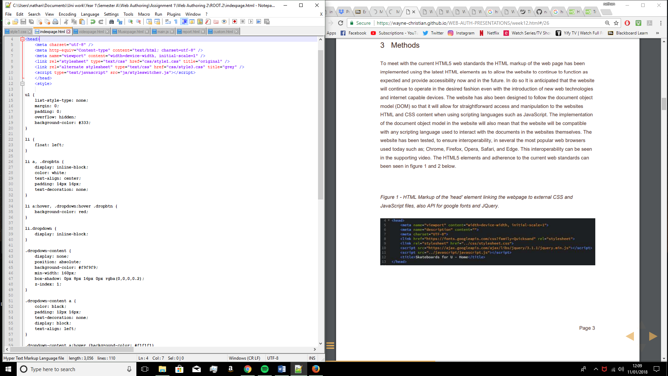

*Figure 1 – The HTML that comprises the head element of the page shows the linking to external CSS and JavaScript files.*

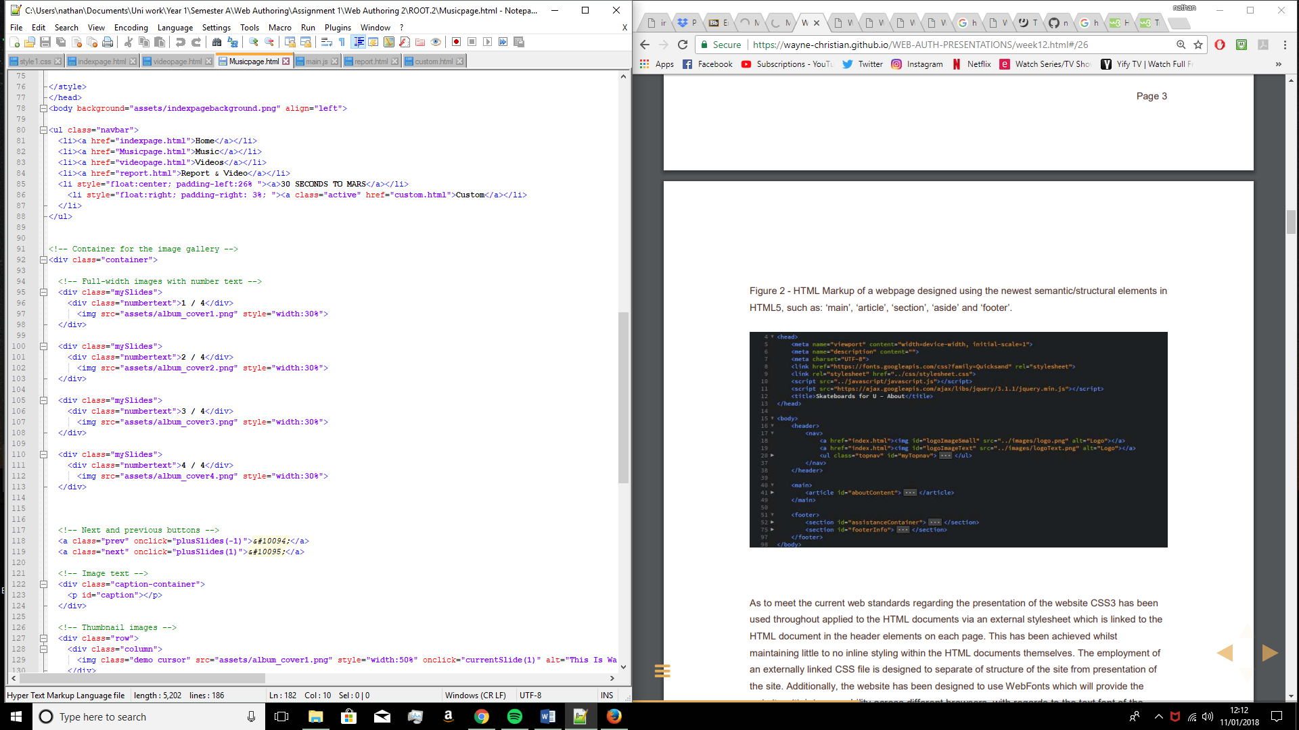*Figure 2 – This image shows the HTML and the structural elements such as the ‘body’, ‘div’ and ‘ul’ tags which set out the sections of the code into clear sections.*

In order to meet with the current web standards in regards to the actual presentation of the website, CSS3 has been applied throughout the entire site and is linked to the pages using the external style sheet as well as some internal style sections, the external links are all contained within the header of the pages. External stylesheets are normally used so that the presentation of the site is kept separate from the actual structure and model, whilst the site does contain some inline styling within the HTML documents the two concepts are still kept quite clearly separated using tags and comments. Cross browser support has been used with the latest CSS3 so that the styles would work across various platforms.

The CSS has also been used to make the website interoperable as it uses styling attributes which allow the website to be responsive to screen size. In order to do this most of the dimensions and scaling has been set to use percentages as opposed to pixels as well as media queries being used to detect screen sizes so that different devices use different styles. By using these techniques the content of the HTML and CSS changes depending on the screen size. In the below figures the media queries can be seen.

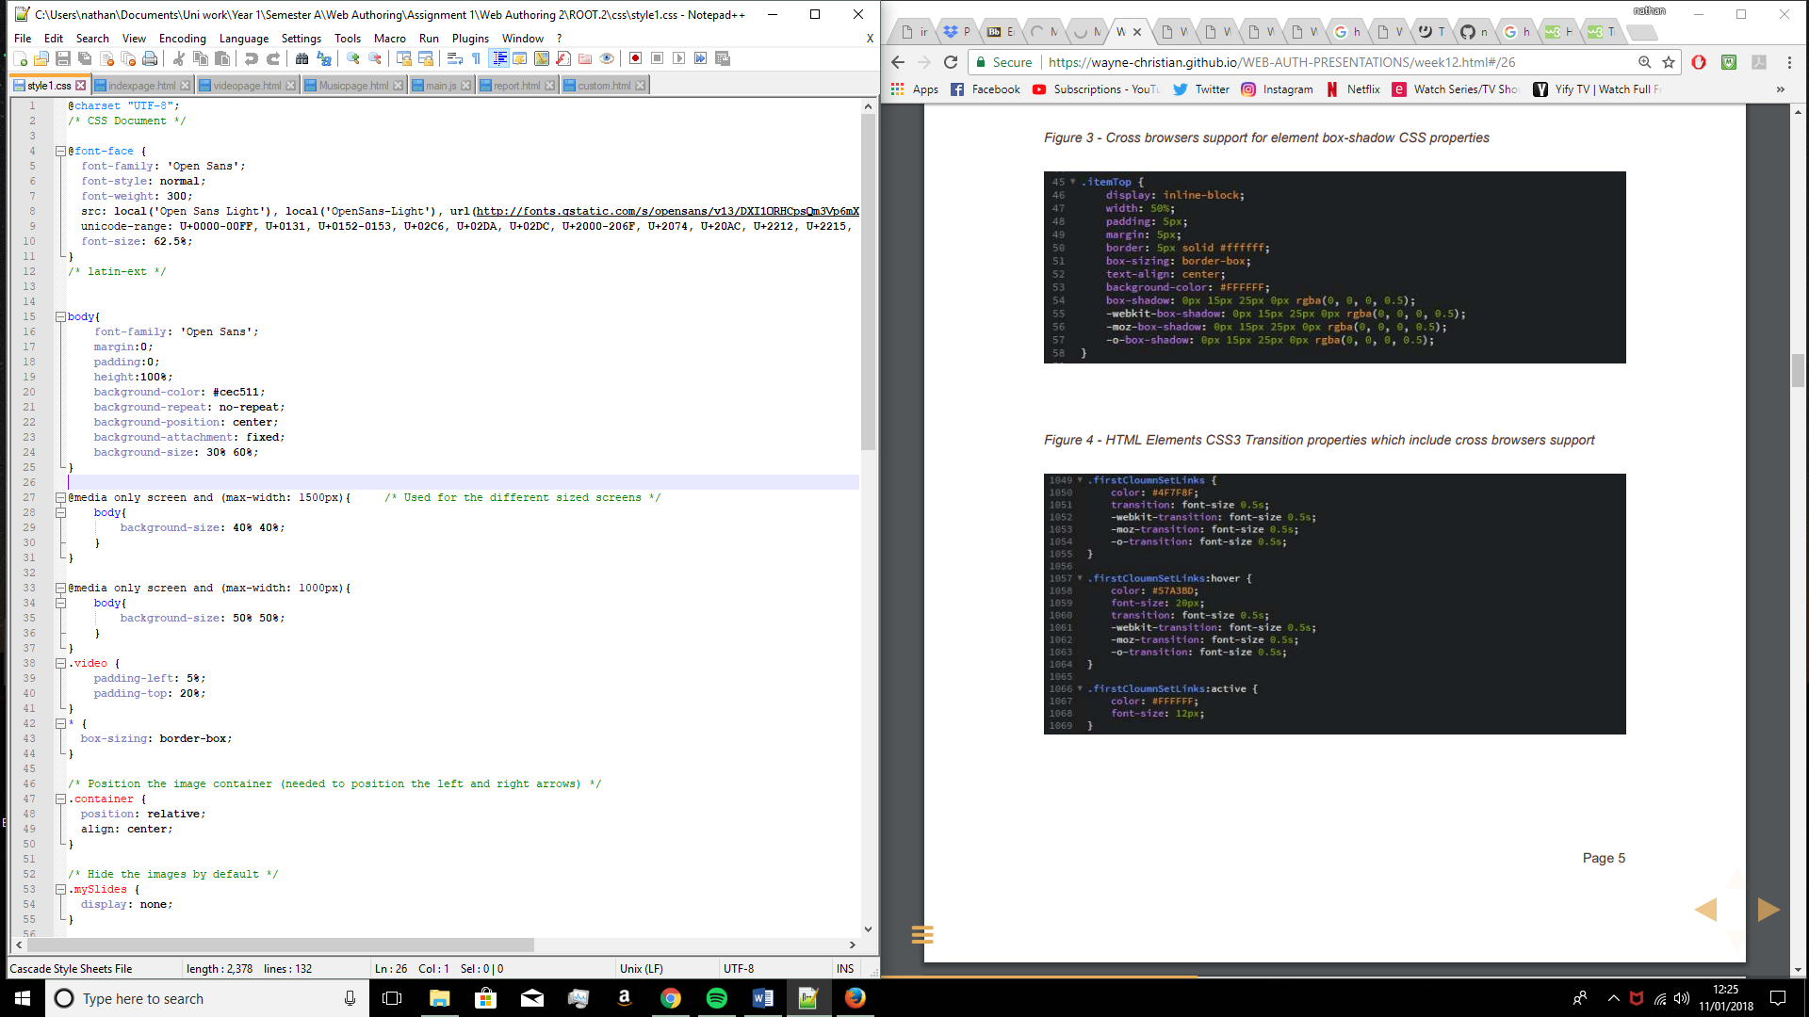

*Figure 3 – In this image the media queries are being used so that depending on the size of the screen a differently scaled background image will be used, this is so that the background image will not be oversized on a mobile device or tablet.*

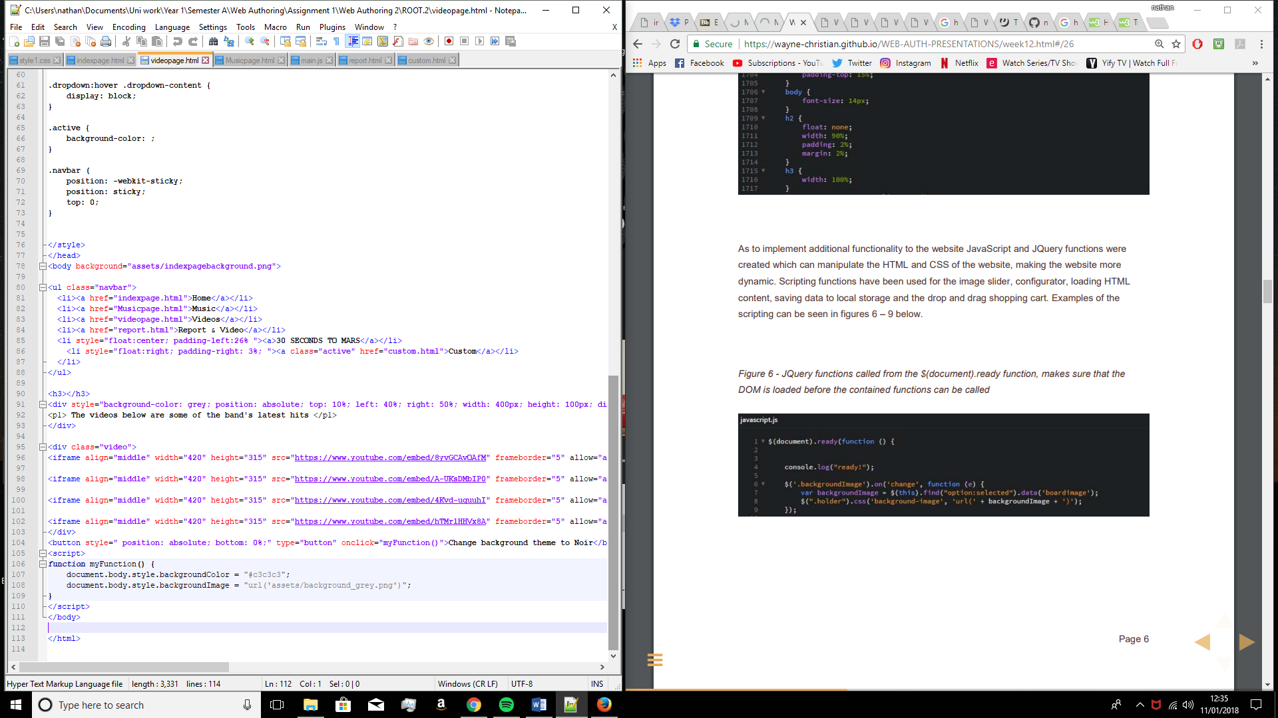In order to implement more functionality, the website also contains JavaScript functions which manipulate both the HTML and CSS content of the website and make the site more dynamic. The JavaScript has been used for the slideshow, geolocator and the background theme changer. As seen in the below figures.

*Figure 4 – The JavaScript function here is used to change the background colours and images in order to change between themes, whilst it is only at two options here, there could be several different options for themes and local storage could be used to save the users preference and apply it across the whole site.*

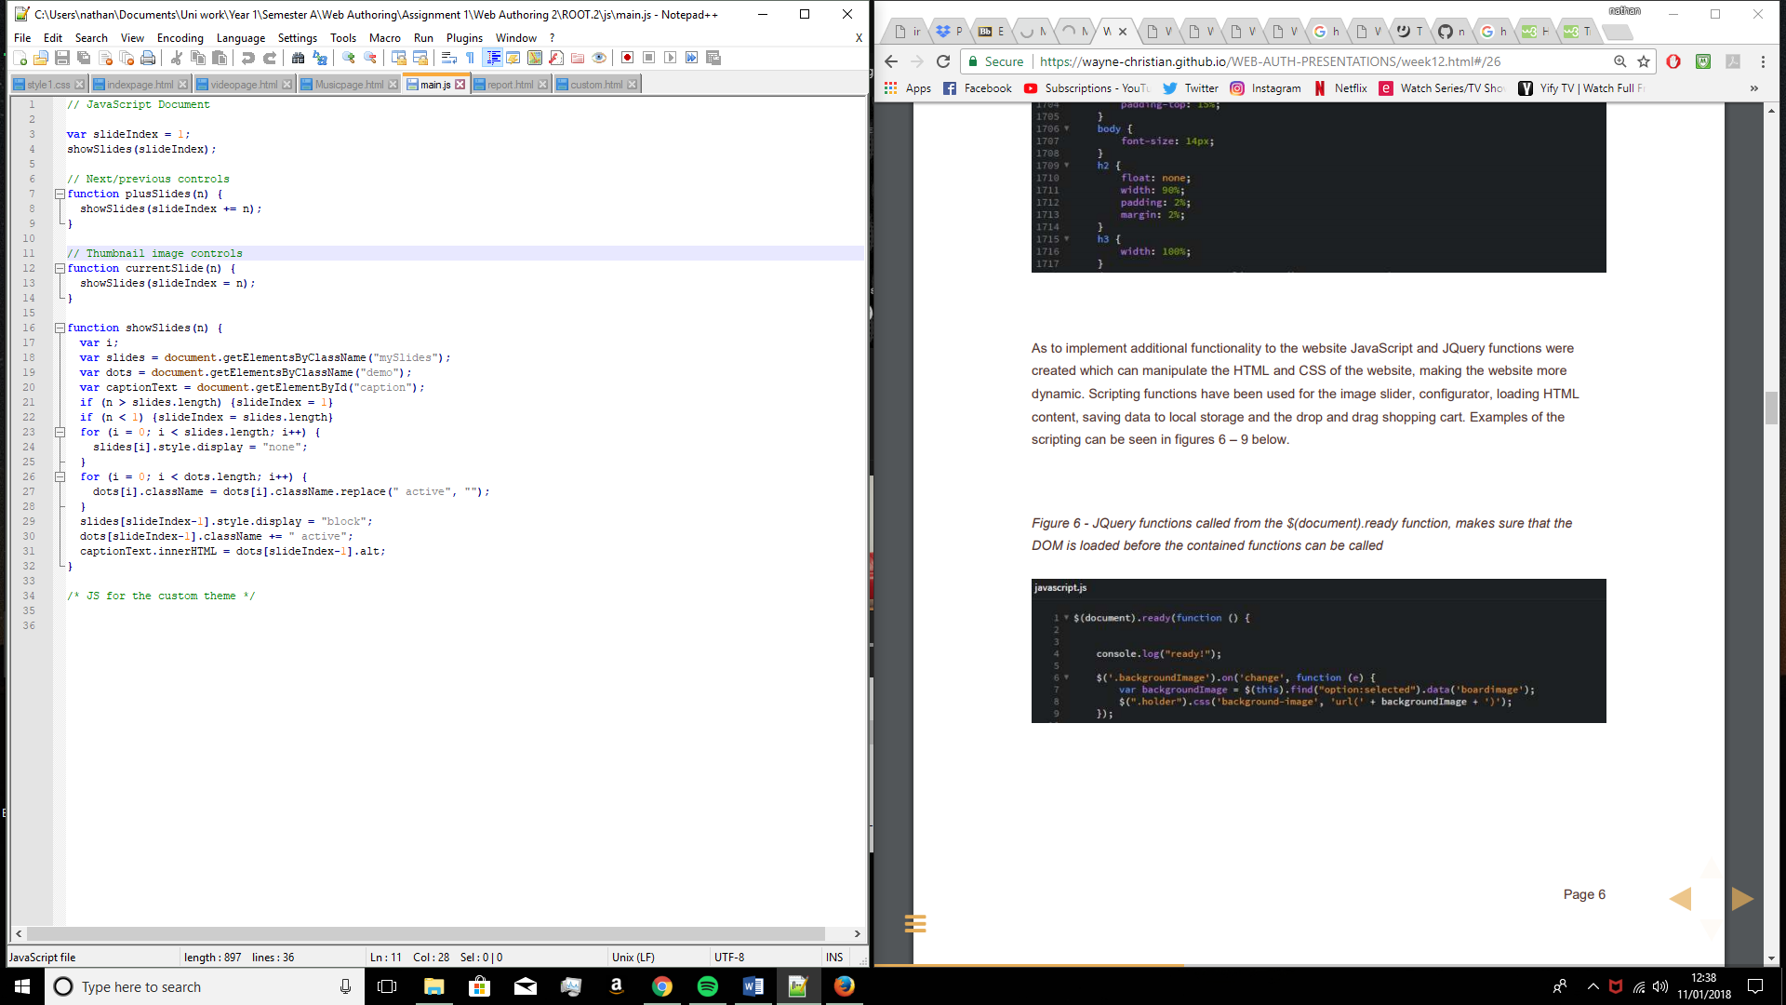*Figure 5 – The JavaScript here is used for the slideshow on the music page, it calls the functions for showing the slideshow images as well as moving between slides using the arrows.*

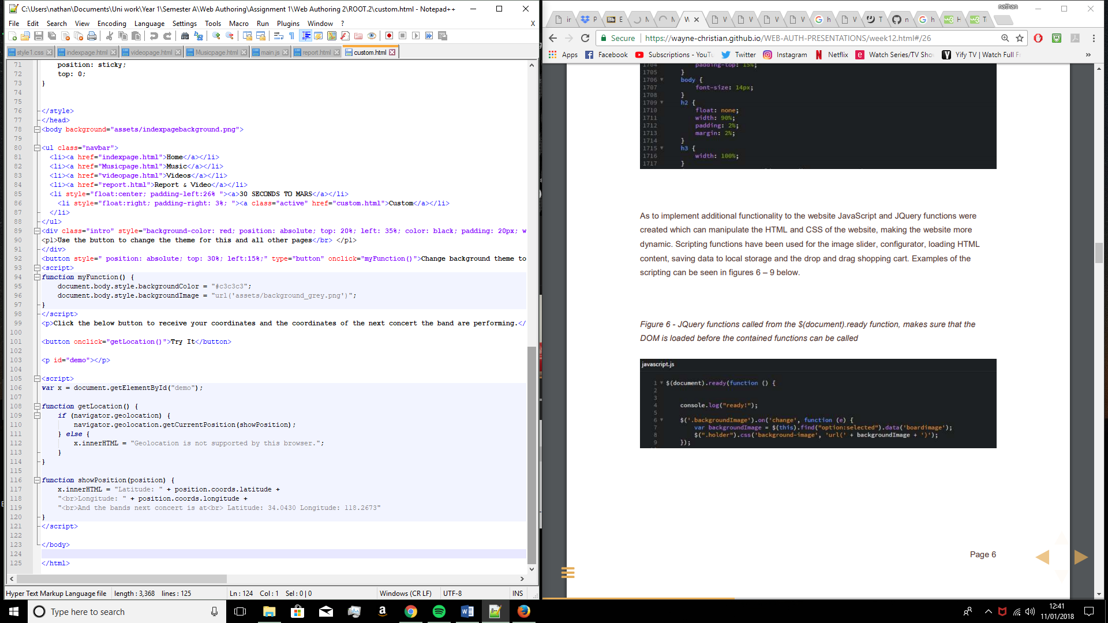

*Figure 6 – This JavaScript is used for the geolocator which displays the user coordinates as well as the coordinates for the next event the band are performing at.*

File Organisation & HTML Validation

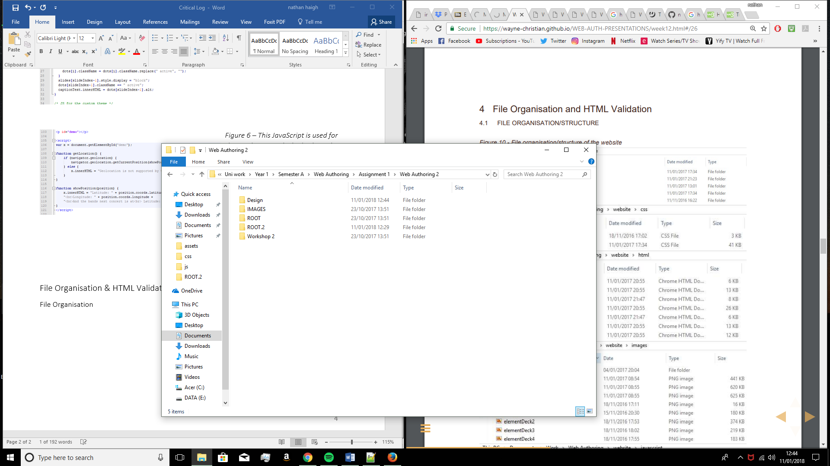File Organisation

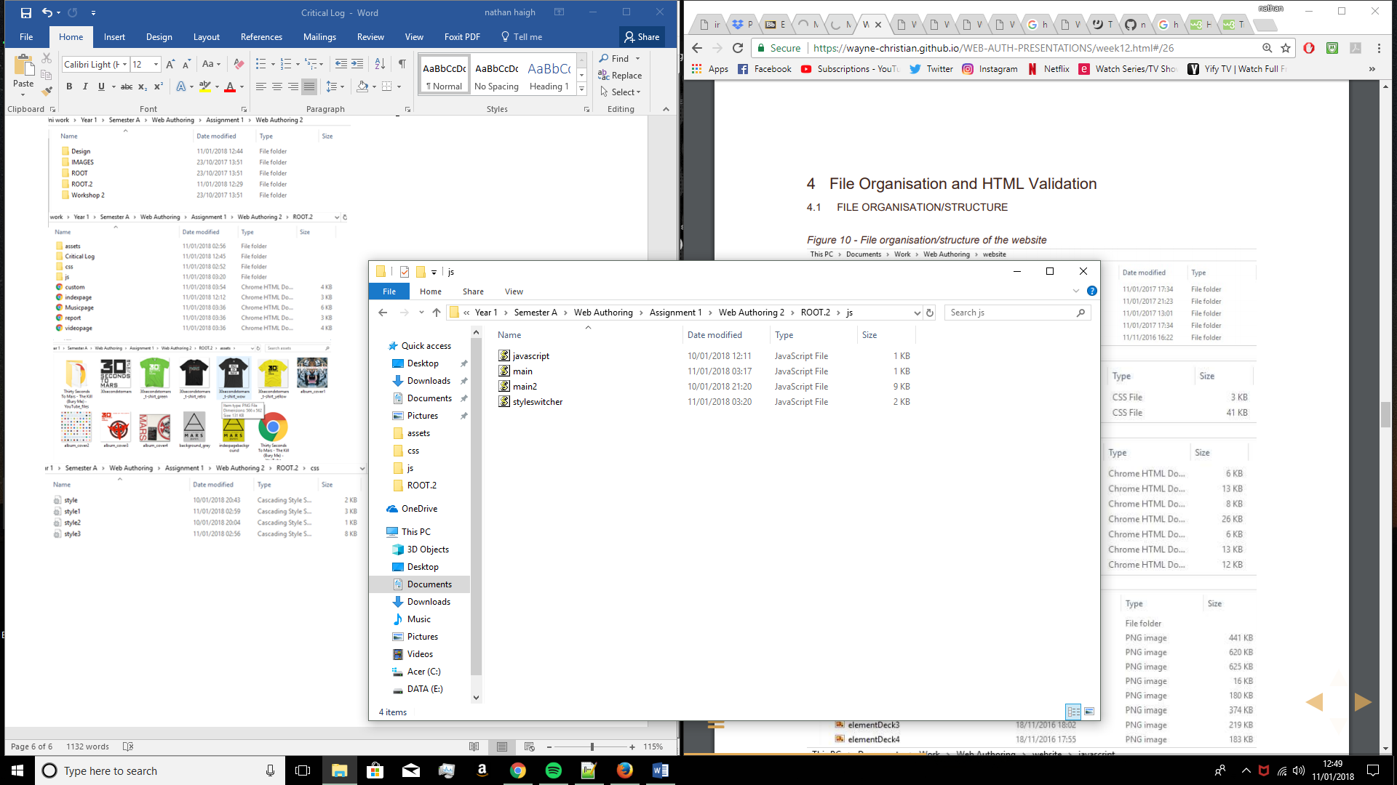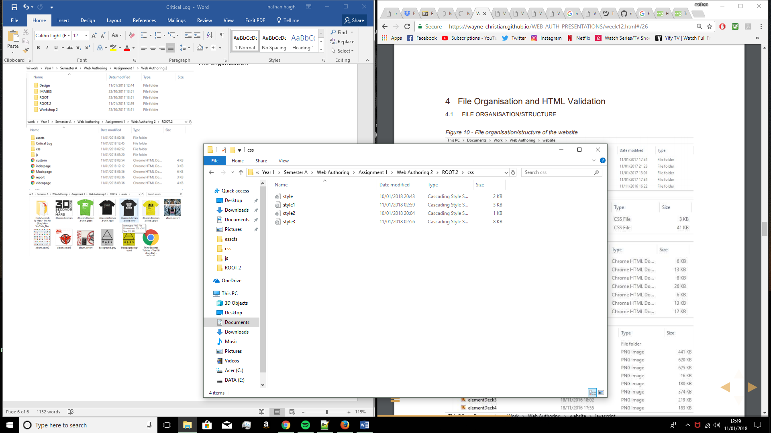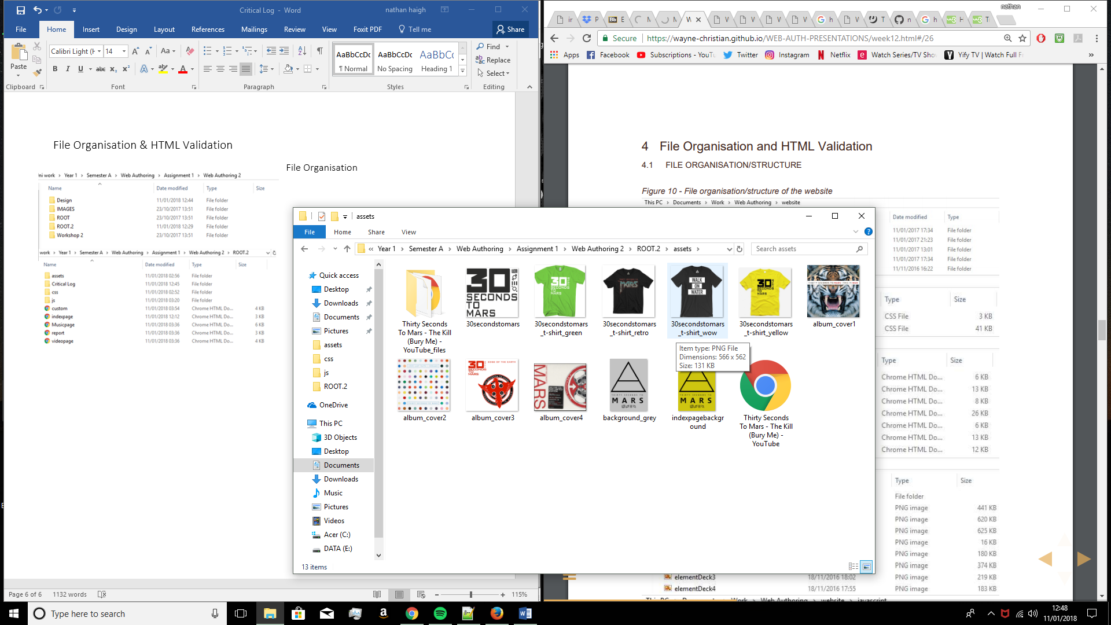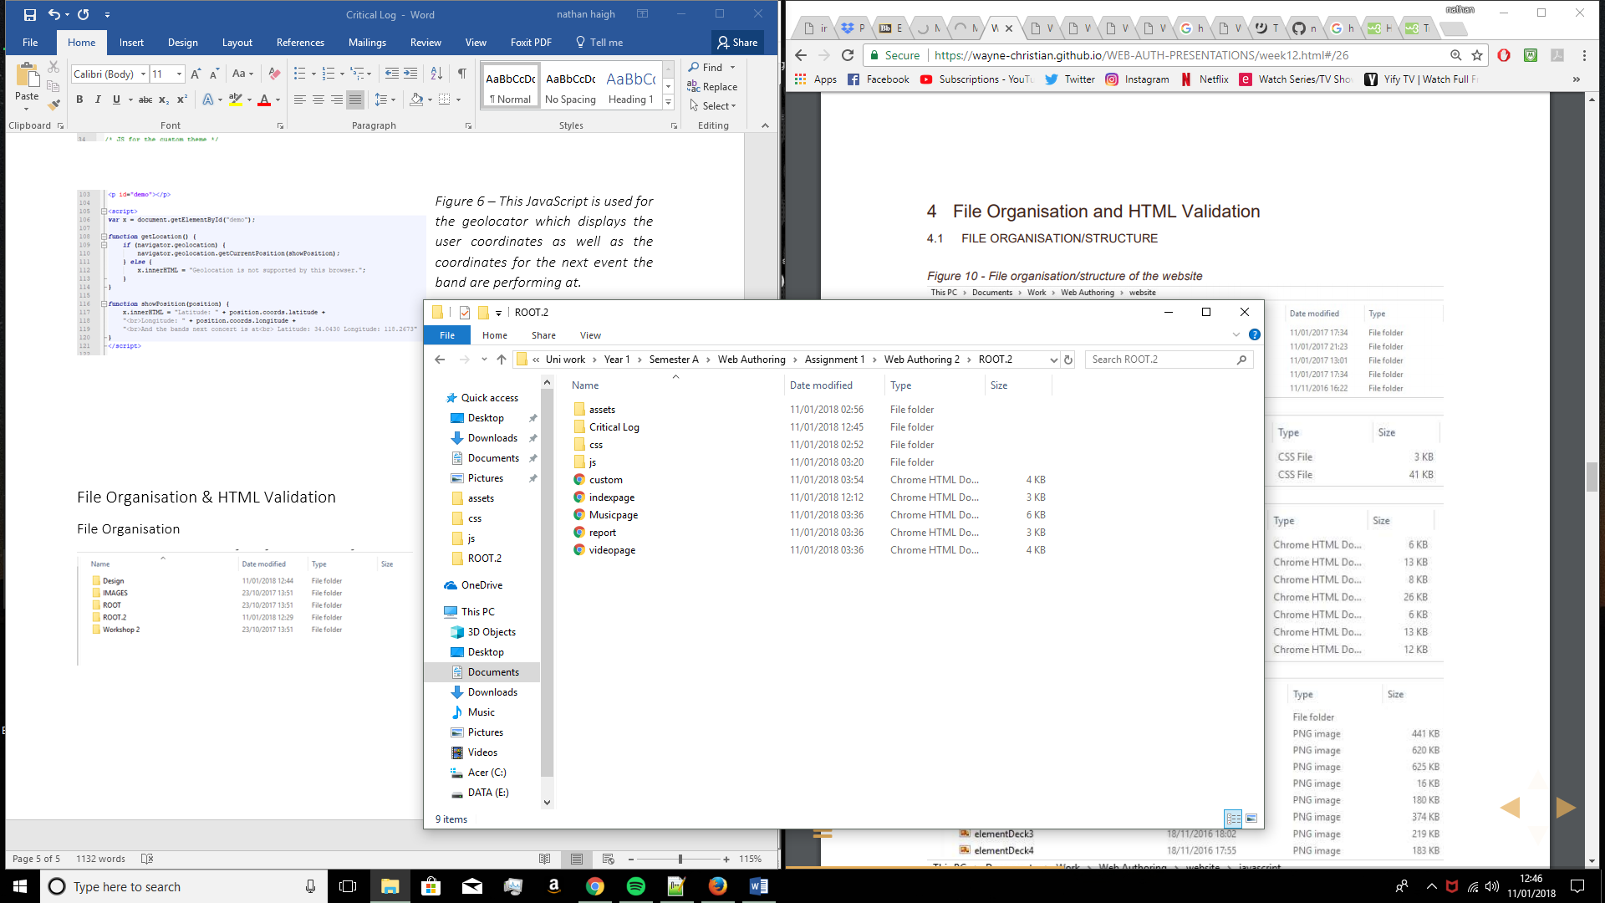

W3C Validation of Website Pages